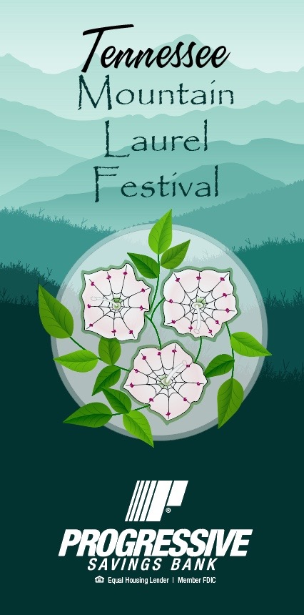

**Saturday May 20**

Quilt Show

Antique Car Show

Treasure Hunt

SideXSide Show

Art Show

Historic Building Tours

Archives

Presbyterian Church

St Paul Lutheran Historic Room

Food and Craft Vendors

Artisan Demonstrations

Blacksmith

Potter

Basketmaker

Rug Hooking

**Guided Mt Laurel Walks**

10 AM Point trail Obed WSC

1 PM Panther Branch Trail FHSP

3 PM Doc Howard Rd Trail-Ridge Rd

Mountain Laurel Gazebo Photos

Ms TN Hot Air Balloon rides

Mt Laurel Window Displays

Silent Auction

Educational Demonstrations

TN Hwy Patrol Seatbelt Safety

Leave No Trace

Entertainment Demos

Secret City Squares (Dance)

CES Maypole Dance

MoCo MoJo Line Dance  
Tenpenny Rapper Sword Dancers



**Pre-Festival Events**

April 20-May 20

Mountain Laurel Marathon Hikes

May 4

Cookies and Canvas Event

May 5

Healthy Walk/Hikewith Missy Kane

May 6

Climb with a Ranger

May 11

Wine and Canvas Event

May 13

Progressive 5k Run/Walk

**Entertainment**

Chill Factor

Calvary’s Men

Big Valley Mustangs

Bradley Carter

Jubal